Computer Networks Lab 04
Name: Hafsa Salman
Roll no. 22K-5161

Task no. 01: Part i
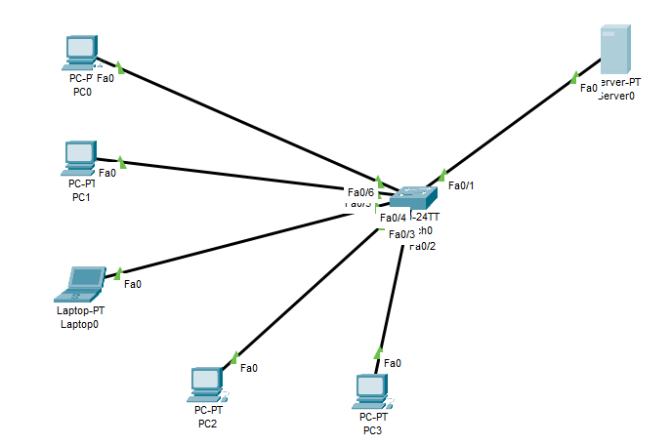

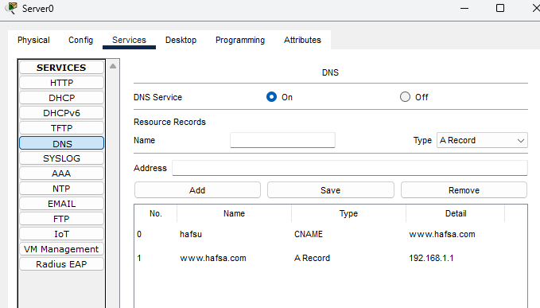

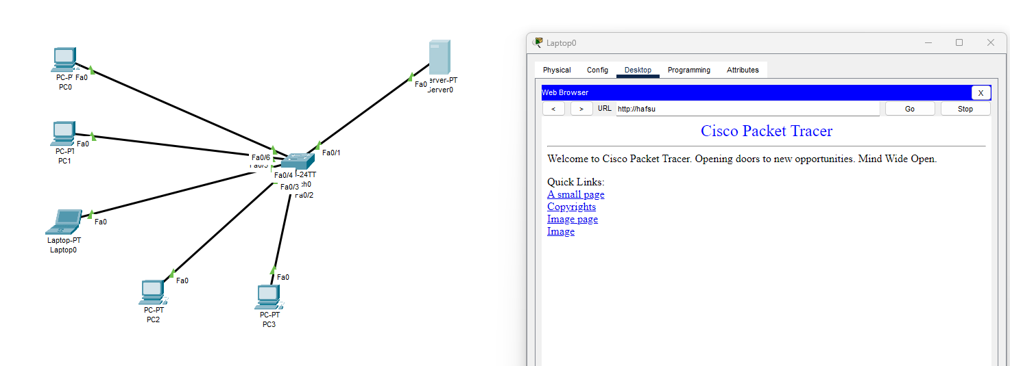

Task no. 01: Part ii
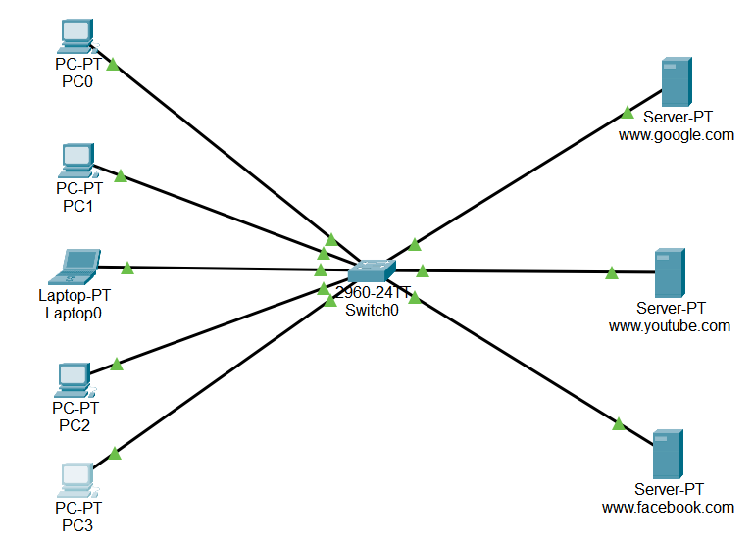
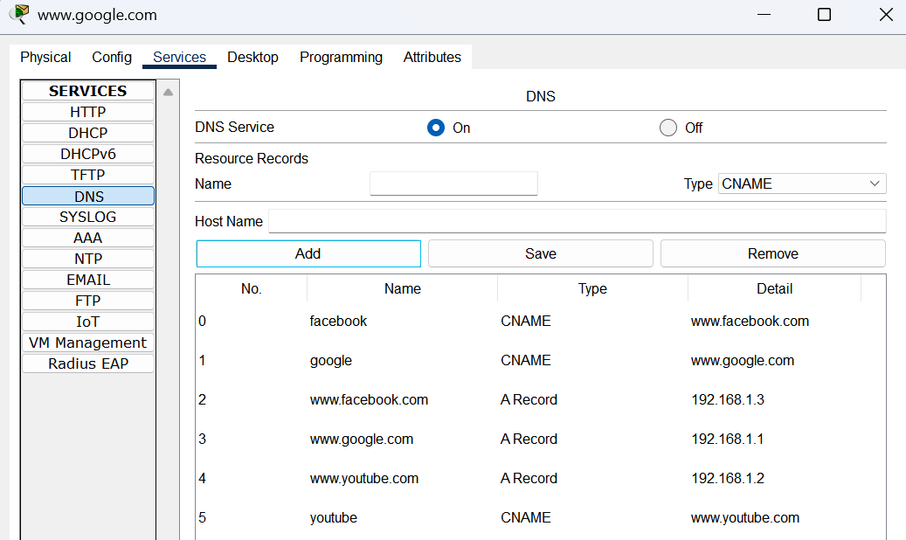
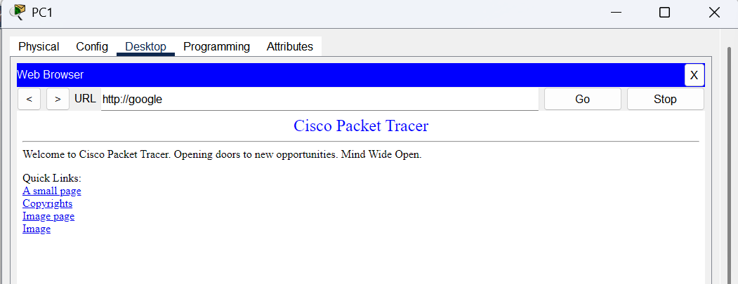
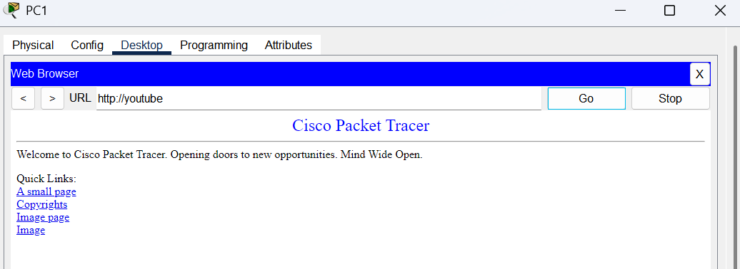
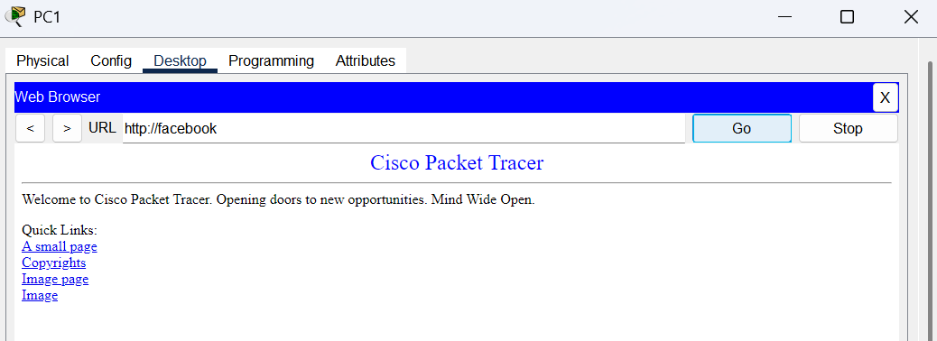

Task no. 02
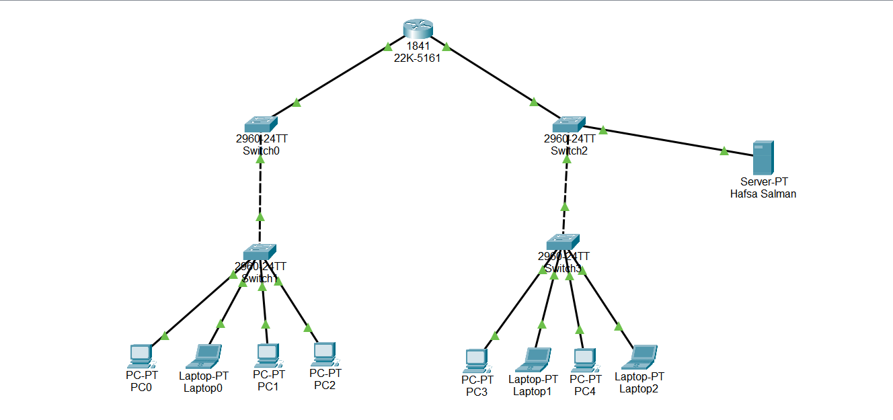
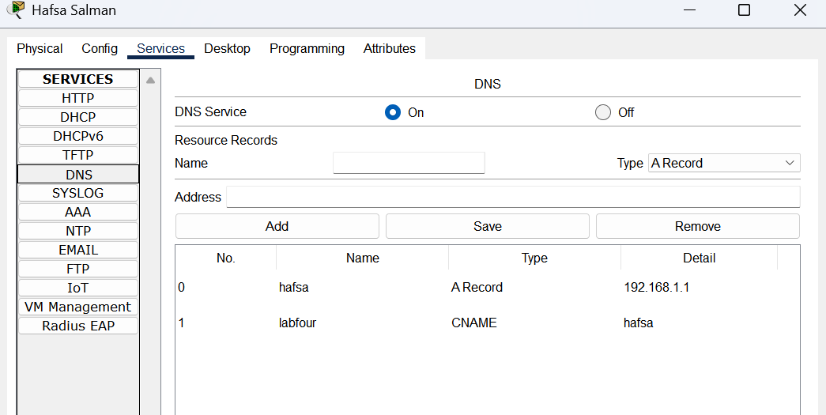
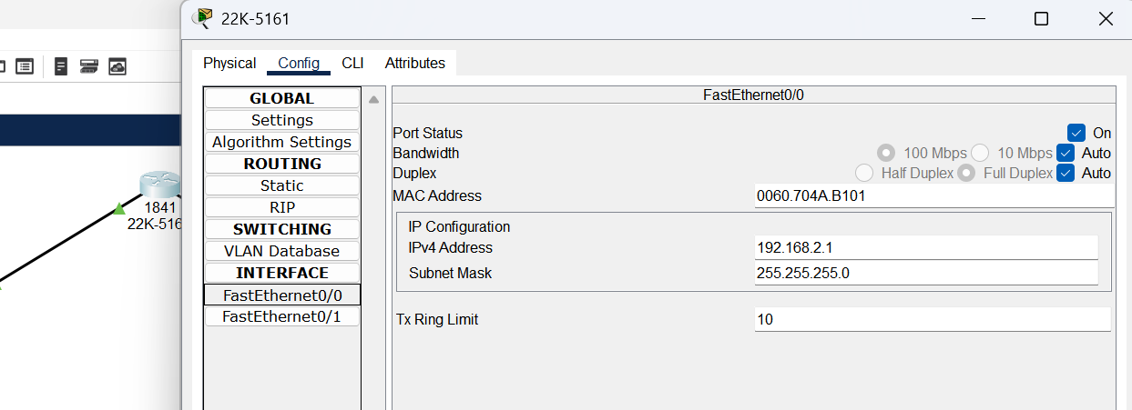
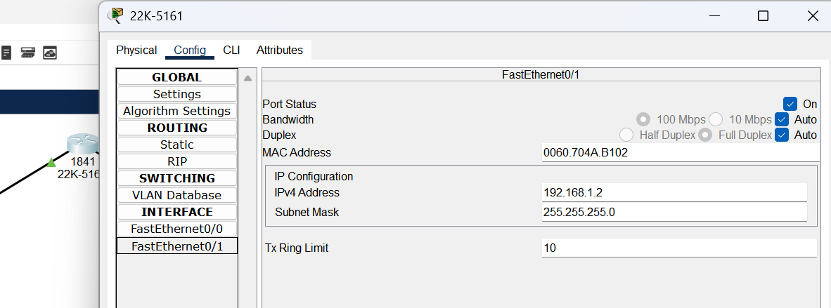
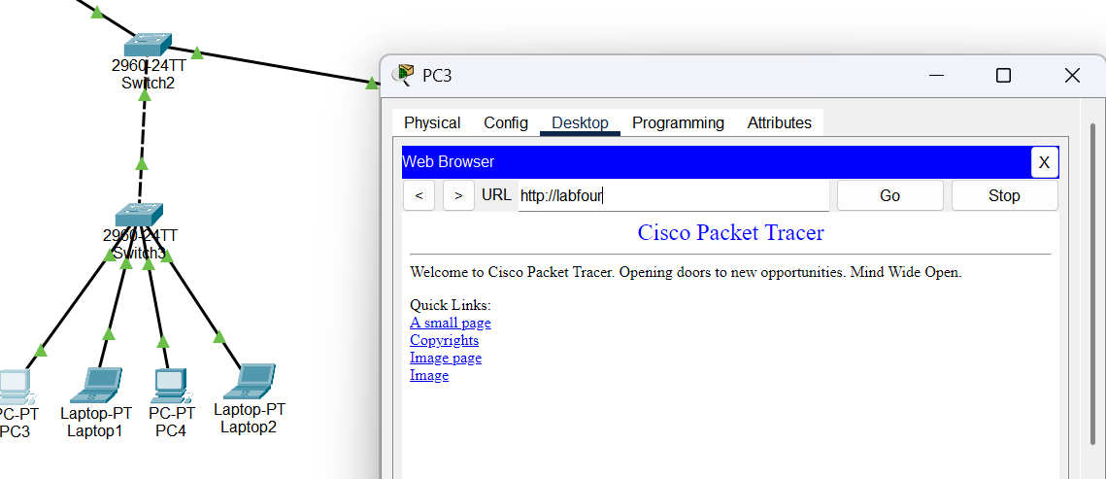
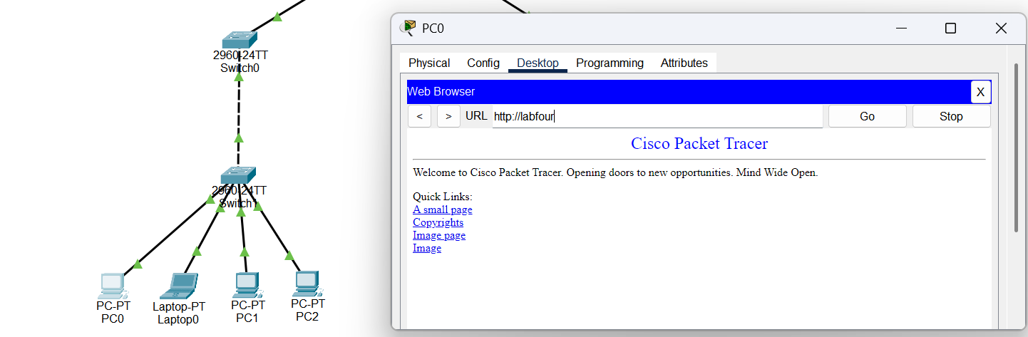

- The age header indicates the time in seconds since the resource has been fetched from the server. It shows how long the resource has been stored. Whereas expires header tells the exact date and time after which the resource is considered stale. It tells when to consider the resource outdated.

- General headers, request headers, response headers and entity headers.

Wireshark Lab Exercise
Task no. 01
Website: www.instagram.com
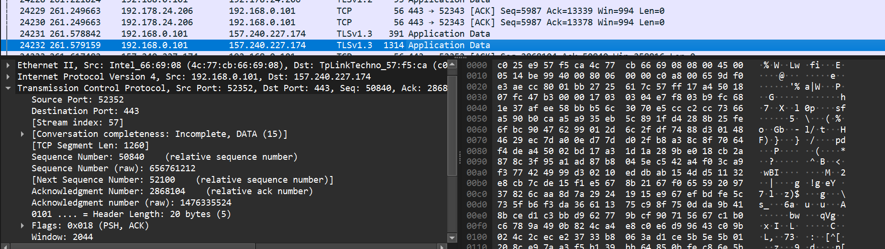
Explanation: HTTPS is secured as it is encrypted.

Task no. 02
Website: http://testphp.vulnweb.com/login.php
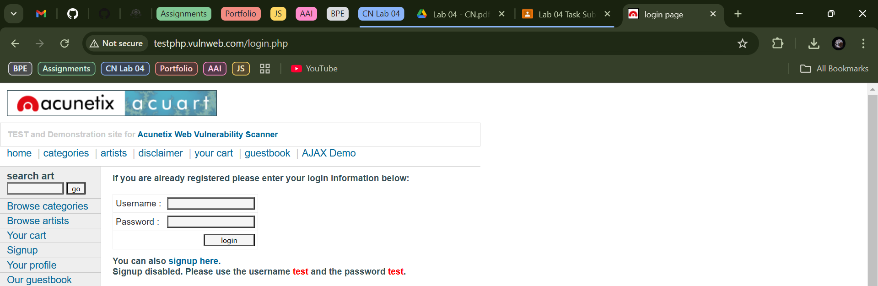
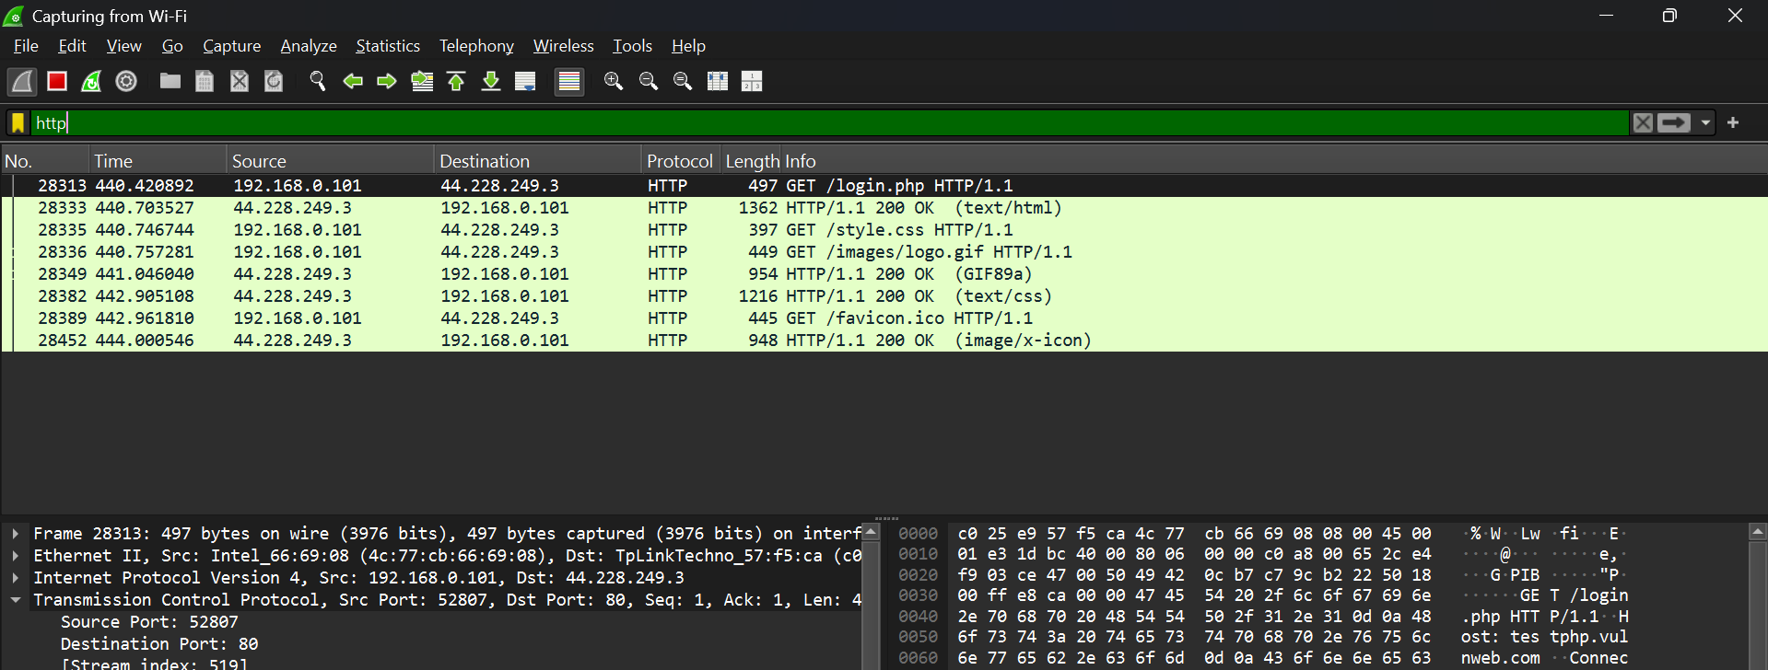
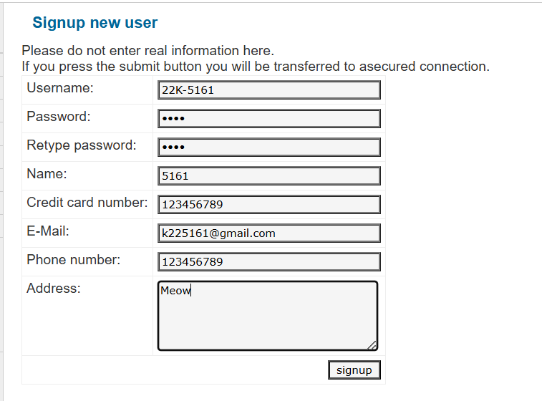
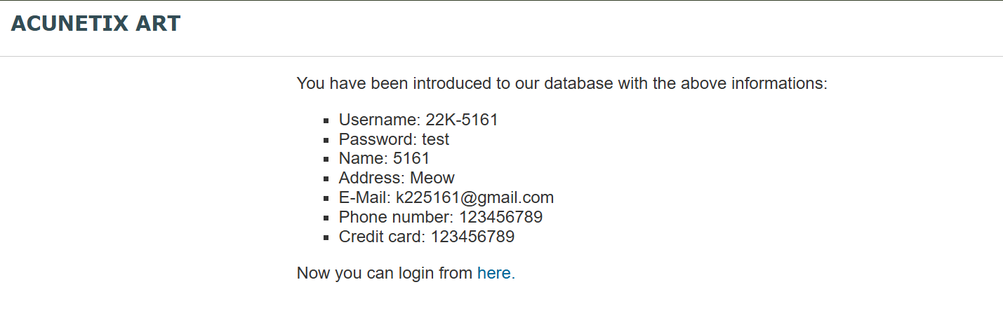
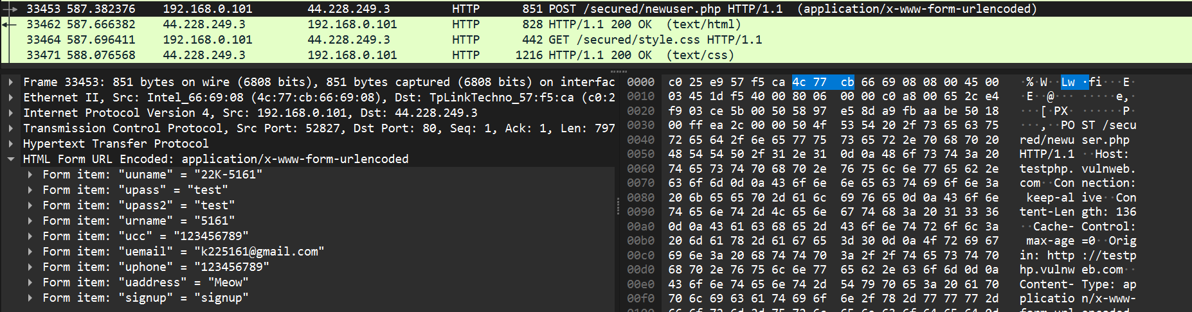

HTTP: It is not encrypted making it unsecure.
HTTPS: It is encrypted which makes the website secure.

